<https://biblioschool.ru/index.php?page=room&tabs=profile>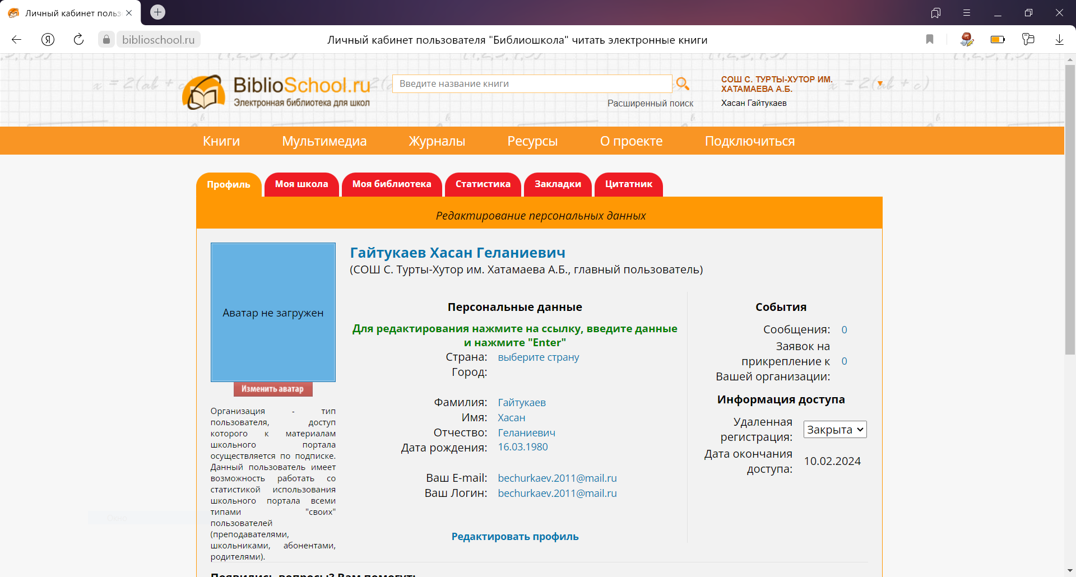

<https://biblioschool.ru/index.php?page=room&tabs=profile>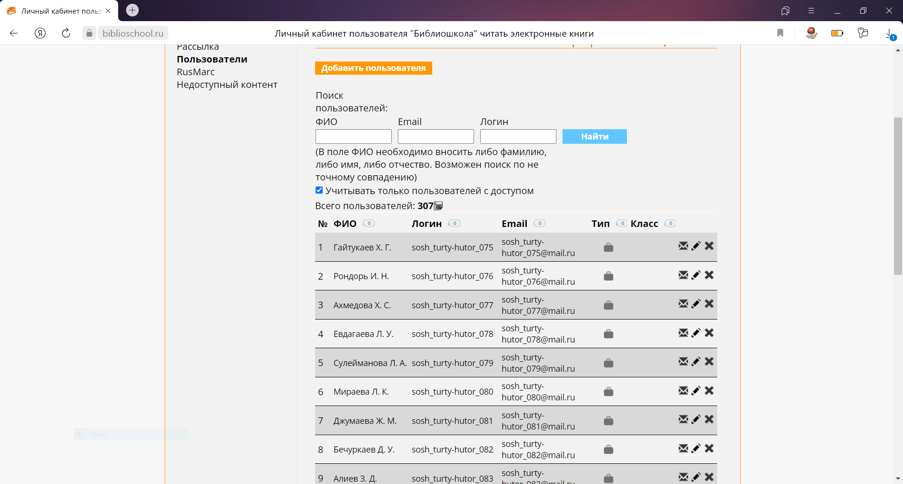

<https://biblioschool.ru/index.php?page=room&tabs=profile>

